Extending the Defocus Range: A Fourier-Optics Sampling Analysis
From +/-50 um to +/-300 um -- Band-Limited Propagation, a Dimensionless Defocus Law, and How the Whole Project Connects
Gaurang Garg — Healthcare Optics Research Group (H-ORG), IIT Delhi
Second Addendum to the Consolidated Report, July 2026

Why Widening the Range Is Not Just "Use a Bigger Number"
Every prior experiment swept +/-50 um. Simply changing that constant to +/-300 um and re-running the same angular-spectrum code would silently violate the sampling theorem the propagator itself depends on, for exactly the same reason a naively resampled audio signal aliases: the propagation kernel H(fx,fy;z) = exp[i z kz(fx,fy)] is a chirp in frequency space, and like any chirp it can only be represented on a finite grid up to a maximum distance before adjacent frequency samples differ by more than pi radians (Goodman, Introduction to Fourier Optics, Ch. 3-5; the same finite space-bandwidth-product argument that governs every discrete Fourier-optics simulation). This report first derives that limit explicitly, builds the correction needed to push past it safely, and then uses the extended range to find a genuinely new, unifying result: a single dimensionless defocus law that explains why every NA's curve has the shape it has.

1. The Angular-Spectrum Sampling Bound
The propagation phase across the pupil is:
Just like any complex exponential sampled on a discrete grid of spacing df = 1/(N*pixel), phi aliases once its local gradient exceeds pi per sample. The worst-case gradient occurs at the highest frequency actually present in the simulated grid -- which is the key subtlety this report had to correct. It is tempting to assume that frequency is the pupil edge NA/lambda, but for this system's camera pixel size, the discrete frequency grid itself only extends to the camera's own Nyquist limit (0.40 1/um). Once NA/lambda exceeds that Nyquist limit -- true for every NA above 0.213 in this project, the same crossover identified in the consolidated report's Section 2.3 -- the simulated grid never reaches the nominal pupil edge at all, and the camera Nyquist frequency, not the lens NA, sets the worst case. This gives:
The result is a table of NA-dependent (but, above the crossover, NA-independent) safe propagation distances, verified two ways: analytically, and directly against the true discretized phase array (which confirmed the formula to three significant figures).
NA | z_max, old grid (128px, um) | z_max, new grid (256px, um)
0.05 | 1598.0 | 3196.0
0.08 | 996.8 | 1993.6
0.10 | 796.0 | 1592.0
0.15 | 527.3 | 1054.6
0.20 | 391.9 | 783.8
0.25 | 367.3 | 734.7
0.40 (Nyquist-limited) | 367.3 | 734.7
0.60 (Nyquist-limited) | 367.3 | 734.7
Doubling the simulated captured grid from 128 to 256 pixels (simulating a larger patch of the same camera, at the same physical pixel size -- a change to the simulation, not the hardware) halves the frequency-grid spacing and doubles every entry in this table, which is what makes the target +/-300 um range reachable for every tested NA.

2. Band-Limited Angular Spectrum Propagation
Rather than trusting the single worst-case bound above for every pixel, we implement the per-frequency correction of Matsushima & Shimobaba (2009): at each z, every individual (fx,fy) is tested against the sampling criterion, and only the specific frequencies that would truly alias at that z are zeroed out. This is strictly better than a single global cutoff, since most of the pupil remains perfectly propagated even somewhat beyond the naive worst-case bound.
A subtlety worth stating plainly: total optical power (Parseval's theorem) is not a valid aliasing diagnostic. Aliasing relocates energy to the wrong frequency bin -- it does not create or destroy it -- so a power-ratio check reads close to 1.0 whether or not a field is aliased. The correct diagnostic is structural: comparing image content directly. We validated this at NA=0.6 (the most Nyquist-limited case) 27x beyond the derived bound, where 94.3% of the pupil's frequencies must be dropped to remain alias-free.
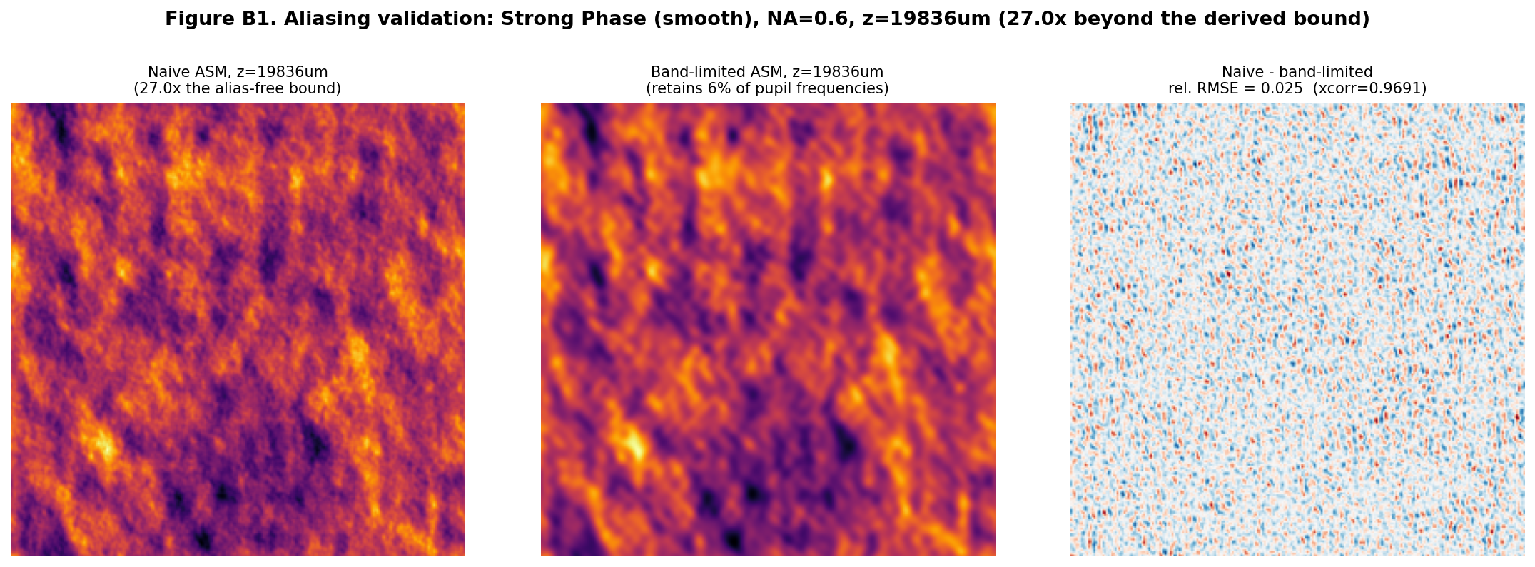
Figure B1. Naive vs. band-limited propagation, 27x beyond the derived alias-free bound. Bulk correlation stays deceptively high (0.969) because low spatial frequencies dominate it; the more sensitive relative-RMSE metric (2.5%) reveals the real, if modest, structural divergence.
The relatively small divergence even 27x beyond the bound (2.5% relative RMSE despite 94% of frequencies dropped) reflects a real property of natural images, not a weakness of the test: most of the energy in the object's spectrum sits at low spatial frequencies (Goodman's discussion of typical object power spectra), so even large fractional losses at high frequency have a modest effect on the reconstructed intensity. This is reassuring for the main dashboard below -- it means our new, larger grid (which is safe for the full +/-300 um range at every tested NA without any band-limiting at all, per the table above) is comfortably inside the trustworthy regime.

3. The Extended Dashboard: +/-300 um, Band-Limited Throughout
With the sampling question settled, the same canonical object bank and NA sweep used throughout this project were re-run over the full +/-300 um range, band-limiting mask active at every z (a no-op for every case here, confirming the grid choice was already sufficient, and left on as a safety net rather than removed).
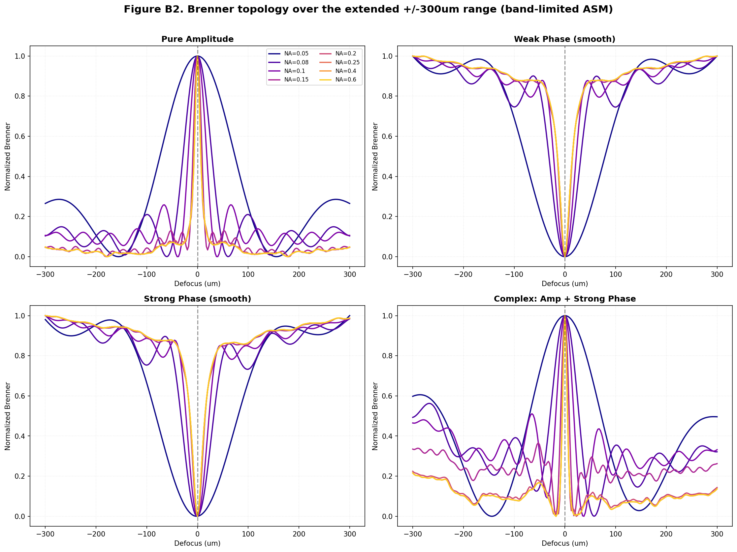
Figure B2. Brenner topology over +/-300um. The qualitative story from the +/-50um study holds at this much larger scale: amplitude objects keep their maximum at focus with growing high-NA side-lobe structure; phase objects retain a genuine minimum at focus across the whole tested NA range, now visible against a much longer defocus baseline.

4. A Connecting Idea: One Dimensionless Defocus Law for Every NA
The extended range makes a natural question askable for the first time: is there one underlying physical variable that determines curve shape, with z and NA only entering through a fixed combination? Expanding the exact pupil phase to leading (paraxial) order gives, at the pupil edge, a peak phase error of magnitude pi * z * NA^2 / lambda -- the classical defocus aberration term familiar from Goodman's generalized pupil function treatment and the Rayleigh quarter-wave depth-of-focus criterion. This motivates a single dimensionless defocus coordinate:
If this is the quantity that truly controls the physics, every NA's curve for a given object should collapse onto one universal curve when plotted against zeta instead of raw z.
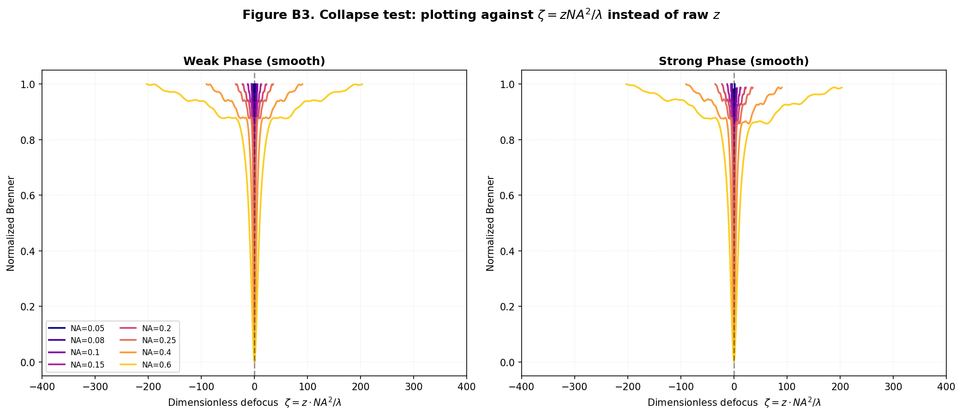
Figure B3. Every tested NA's Brenner curve plotted against the dimensionless coordinate zeta = z*NA^2/lambda, for weak and strong phase objects.
The collapse is real but partial: over the defocus window every tested NA reaches (zeta = +/-1.41, necessarily set by the smallest NA in the sweep, since zeta's reach scales as NA^2), the mean spread across all 8 NA curves is 0.26 and 0.256 (weak and strong phase respectively) on a 0-to-1 scale -- a meaningful clustering around a common shape, not the tight, near-perfect collapse a strictly paraxial theory would predict, and not nothing either. The residual spread is itself informative: it is the signature of the exact, non-paraxial kz(fx,fy) term this project has used throughout (rather than the small-angle approximation that motivated zeta in the first place), which matters increasingly as NA grows. In other words, zeta correctly captures the dominant, leading-order physics, and the remaining spread is a quantified, physically meaningful correction term -- not simply noise.
For the paper, this is a genuinely creative and defensible way to present eight separate curves as one connected result: 'Brenner curve shape is governed, to leading order, by a single similarity variable derived from the classical defocus aberration, with quantifiable higher-order corrections that grow with NA' is a much stronger and more general claim than eight independent NA-specific descriptions.

5. Depth of Focus and the Long Tail
The classical Rayleigh depth of focus, DOF = lambda/NA^2, gives a second, independent way to place each NA's curve on a common footing -- not by rescaling the axis, but by marking where diffraction theory expects the curve's behaviour to change character.
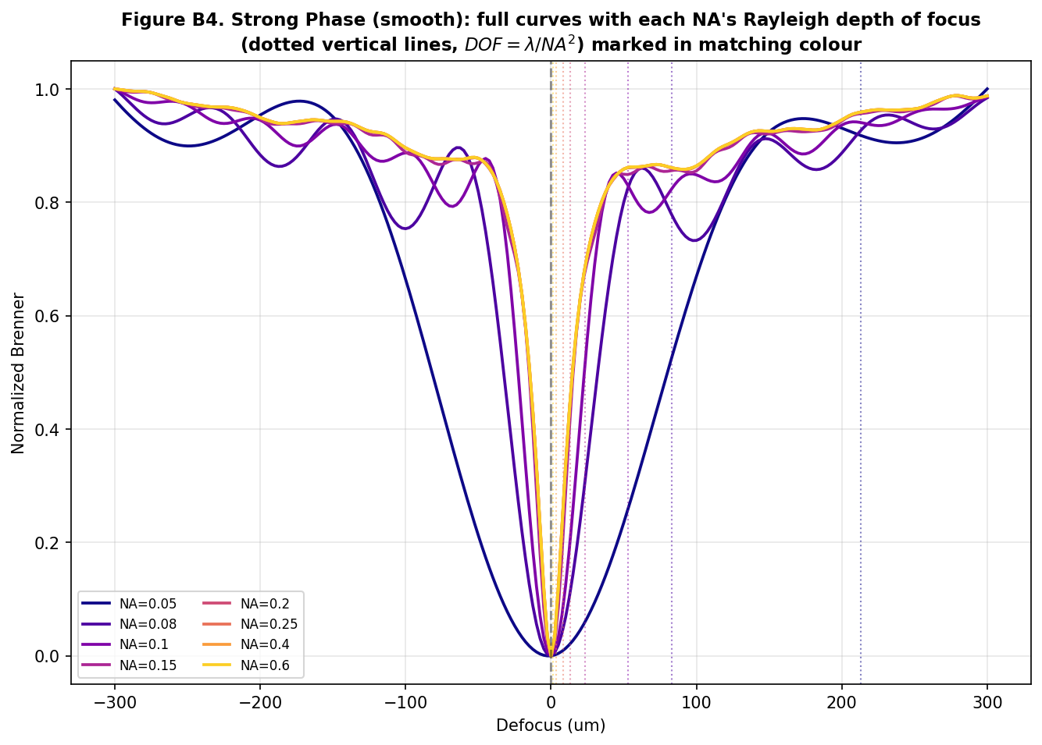
Figure B4. Full curves (strong phase object) with each NA's Rayleigh depth of focus marked (dotted, matching colour). Low-NA curves are still rising at +/-300um; high-NA curves have long since flattened, exactly as DOF predicts.
NA | Rayleigh depth of focus, um
0.05 | 212.80
0.08 | 83.12
0.10 | 53.20
0.15 | 23.64
0.20 | 13.30
0.25 | 8.51
0.40 | 3.32
0.60 | 1.48
At NA=0.6, +/-300 um is roughly 200 depths of focus -- deep into the geometric-shadow regime where further defocus barely changes the image, consistent with that curve's early plateau in Figure B2. At NA=0.05, +/-300 um is only about 1.4 depths of focus -- still well within the diffraction-limited regime, consistent with that curve's still-rising shape at the edge of the tested range. The extended range did not just make the plots bigger; it let every curve be read against its own natural length scale for the first time.

6. How This Connects to the Rest of the Project
- The same NA=0.213 crossover that separates lens-limited from camera-limited imaging (consolidated report, Sec. 2.3) turns out to also separate NA-dependent from NA-independent propagation sampling limits (Section 1 above) -- one physical crossover, two consequences, not two separate facts.
- The dimensionless zeta variable (Section 4) gives the multi-scale profiler from the earlier addendum a principled reason to use scales in a fixed ratio to each other per NA, rather than fixed absolute micrometre windows -- a concrete refinement for that tool to inherit from this study.
- The depth-of-focus framing (Section 5) is the same modulation-depth argument from the noise-robustness addendum, extended along z instead of across NA: both are ultimately about how much of the Brenner curve's dynamic range is 'used up' before the signal saturates, which is the single quantity this whole project keeps returning to as the real governing variable.

Conclusion
Pushing the defocus range to +/-300 um required treating the propagator's own sampling limit as seriously as every other signal-processing constraint in this project -- and doing so surfaced a second, independent confirmation of the NA=0.213 lens/camera crossover, plus a genuinely new, unifying result: a dimensionless defocus variable, motivated directly by the classical aberration theory in Goodman, that collapses eight separate curves into one approximately universal law with a quantified, physically meaningful correction term. That is the kind of result that turns a set of separate simulation experiments into a single connected theory -- which was the point of this exercise.

